# Learner Preparation – SAS

Active participation in the SAS part of this workshop requires a SAS profile.

* In case you do not have a SAS profile, create it here:  
  <https://www.sas.com/profile/ui/#/create>  
  You will get an email with the subject: **Please activate your SAS Profile**
* Once your SAS profile has been created, sign in to: <https://communities.sas.com/> and finalize your profile.
* Set up SAS On-Demand account by signing in with your SAS profile at: <https://welcome.oda.sas.com/>  
  This might take 10 minutes, after which you will receive an email:  
  **You are ready to start using SAS OnDemand for Academics**
* You can either
  + Click the blue button to **Launch** SAS Studio

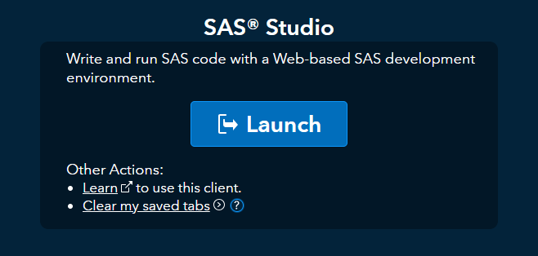

In the CODE screen enter some code:

proc print data=sashelp.class;  
run;

Then press the ‘running person’ button.  
You should get a RESULT: